**LAGORO SEED SECONDARY SCHOOL**

**END OF TERM II 2024**

**S.3 CHEMISTRY**

**TIME: 1HOUR AND 30MINUTES**

SECTION A

Item 1

Ocira Bosco is a well-known motorcycle mechanic working in one of the garages in Northern Uganda ; he finds difficulty in washing his clothes after work using tap water and detergent, he thus lives a frustrated life.



Task.

a) As a chemistry learner, help Ken to find out

i)The category of the product he chooses

…………………………………………………………………………………………………………………………………………………………………………………………………………………………………………………………………………………………………………( 2 scores)

ii)The suitability of the product.

………………………………………………………………………………………………………………………………………………………………………………………………………………………………………………………………………………………………………………………………………………………………………………………………………………………………………………………………………………………………………………………………………………………………………………………………………………………………………………………………………………………………………………………………………………………………………………………………………………………………………………………………………………………………………………………………………………………………………………………………………………………………………………………………………………………………………………………………………………………………………………………………………………………………………………………………………………………….(3 scores)

b) advise Ken on the challenges associated with the long-term use of the product he uses.

………………………………………………………………………………………………………………………………………………………………………………………………………………………………………………………………………………………………………………………………………………………………………………………………………………………………………………………………………………………………………………………………………………………………………………………………………………………………………………………………………………………………………………………………………………………………………………………………………………….

………………………………………………………………………………………………………………………………………………………………………………………………………………………………………………………………………………………………………….(5 scores)

Item 2

The Ministry of Education and Sports has recently taken over the ownership of one of the existing community school and the parents are being tasked to contribute building materials for constructing a temporary classroom structure but they find difficulty in choosing good quality materials.

Task

a)As a chemistry student, help the parents

i)in selecting the category of good quality materials.

…………………………………………………………………………………………………………………………………………………………………………………………………………………………………………………………………………………………………………..(2 scores)

ii)Find out the properties of the materials selected.

………………………………………………………………………………………………………………………………………………………………………………………………………………………………………………………………………………………………………………………………………………………………………………………………………………………………………………………………………………………………………………………………………………………………………………………………………………………………………………………………………………………………………………………………………………………………………………………………………………………………………………………………………………………………………………………………………………………………………………………………………………………………………………………………………………………………………………………………………………………………………………………………………………………………………………………………………………………..(4 scores)

b) Prolonged use of materials can impact the environment, advise the parents.

…………………………………………………………………………………………………………………………………………………………………………………………………………………………………………………………………………………………………………………………………………………………………………………………………………………………………………………………………………………………………………………………………………………………………………………………………………………………………………………………………………………………………………………………………………………………………………………………………..(4 scores)

SECTION B

Part 1

Attempt any one item from this section

Item 3

There is an ongoing campaign by the government officials to stop the cutting down of trees by the residents Northern Uganda who have been cutting down trees to get firewood as fuel. The Local government leaders are urging the residents to set up bio gas production plants but with minimal environmental impact.

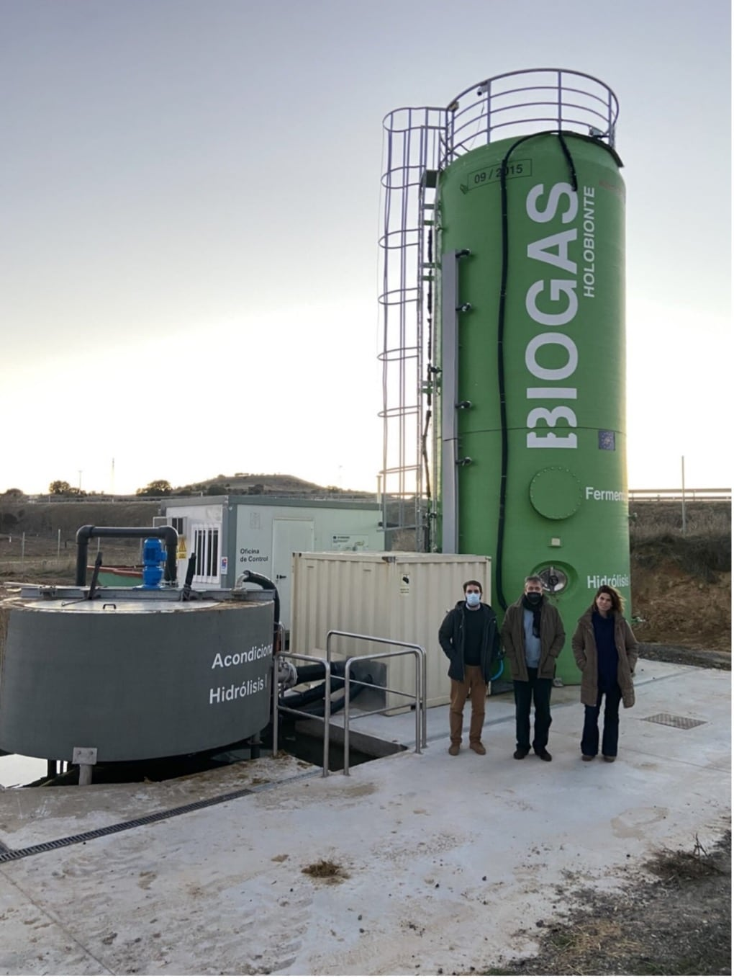

The chairperson of Environmental department has selected you to sensitize the residents about bio gas production through several workshops.

Task

Write a message you would present to the residents

Item4

As a result of poor discharge of wastes in a lake, there has been rapid plant growth over the water surface reducing oxygen supply to the aquatic life beneath” It is only adequate supply of oxygen below water that can save aquatic life”, A local investor has been cleared by the government to set up oxygen production plant near the lake but the residents area against the idea. 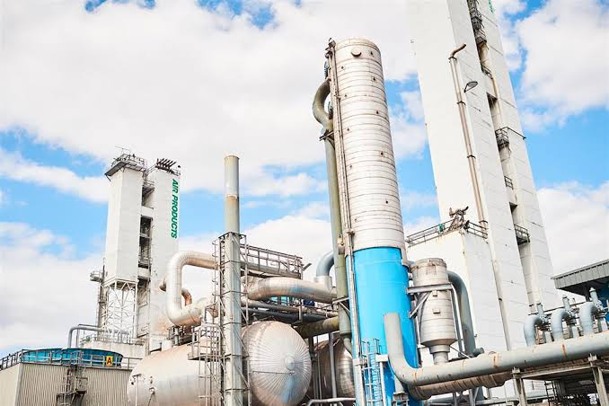

The head of department chemistry has appointed you to go and sensitize the residents about the oxygen production plant and how it would impact them.

Task

Make a write up of the presentation you will deliver.

END